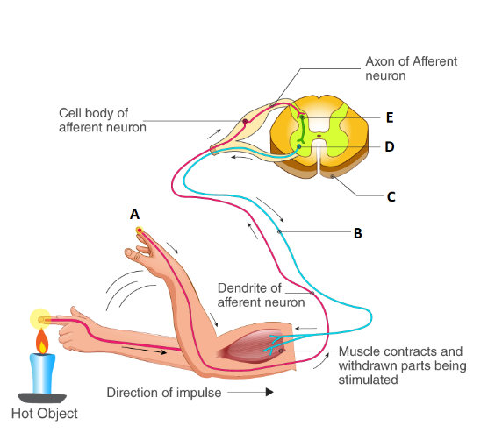
The diagram is of:
A. Reflex arc
B. Synapse
C. Spinal cord
D. Sensory receptor
ANSWER: A
The receptors stimulate a
A. Receptors
B. Sensory neuron
C. Interneuron
D. effector
ANSWER: B
The ___________ stimulates a sensory neuron
A. Receptors
B. Motor neuron
C. Interneuron
D. effector
ANSWER: A


Identify what A represents in the given diagram
A. Cell body of efferent neuron
B. Spinal cord
C. Axon of efferent neuron
D. Pain receptors in skin
ANSWER: D

Identify what B represents in the given diagram
A. Cell body of efferent neuron
B. Spinal cord
C. Axon of efferent neuron
D. Pain receptors in skin
ANSWER: C
A typical reflex arc includes ______fundamental parts
A. 8
B. 2
C. 5
D. 3
ANSWER: C
A typical reflex arc includes:
A. Receptors, sensory neurons
B. Interneurons
C. motor neurons, effectors
D. All of these
ANSWER: D
_________ in the skin of the hand are activated by the heat of the object
A. Receptors
B. Sensory neurons
C. Interneurons
D. effectors
ANSWER: A

Identify what C represents in the given diagram
A. Cell body of efferent neuron
B. Spinal cord
C. Axon of efferent neuron
D. Pain receptors in skin
ANSWER: B

Identify what D represents in the given diagram
A. Cell body of efferent neuron
B. Cell body of interneuron
C. Axon of efferent neuron
D. Pain receptors in skin
ANSWER: A
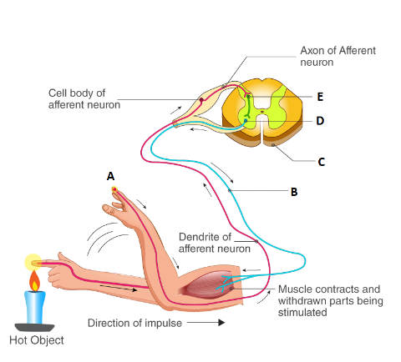
Identify what E represents in the given diagram
A. Cell body of efferent neuron
B. Cell body of interneuron
C. Axon of efferent neuron
D. Pain receptors in skin
ANSWER: B
A typical neuron consists of:
A. cell body (soma),
B. dendrites
C. axon
D. All of these
ANSWER: D
___________respond to stimuli such as touch, sound, or light that affect the cells of the sensory organs
A. Sensory neurons
B. Interneurons
C. Motor neurons
D. neurons
ANSWER: A
__________connect neurons to other neurons within the same region of the brain or spinal cord
A. Sensory neurons
B. Interneurons
C. Motor neurons
D. neurons
ANSWER: B
____________ nerve pathway takes signals from CNS to effector organs.
A. Afferent
B. Efferent
C. Sensory
D. None of these
ANSWER: B
____________nerve pathway takes signals from receptors to CNS
A. Afferent
B. Efferent
C. Motor
D. None of these
ANSWER: A

